Pricing app primarily contains Pricing CRUD (Create/Read/Update/Delete), Import and Reporting function. Pricing app has four types: Pricing Options (PS), Client Pricing Options (CS), Client Pricing Rate Sheet (CR) and MIC options (MP).

- Pricing Application overview.

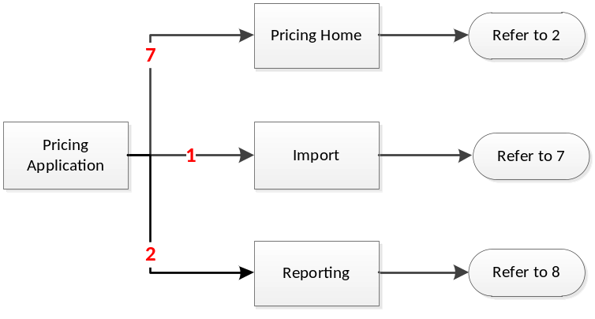

- Pricing Home

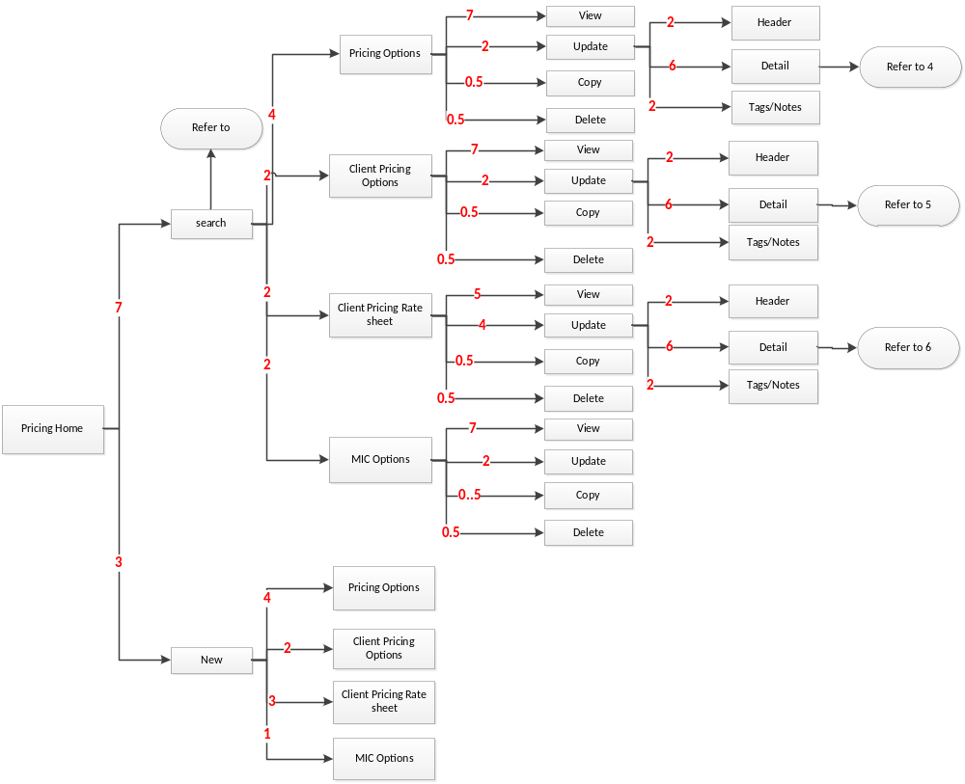

- Search Pricing Components

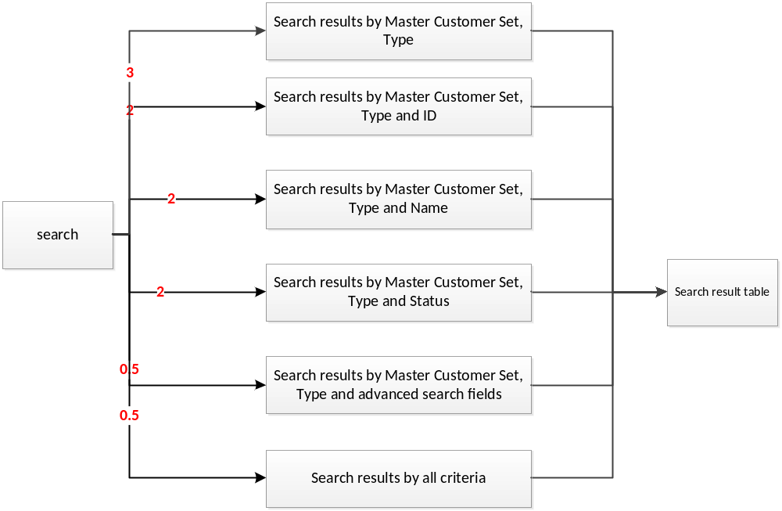
- Pricing Options – Detail Tab

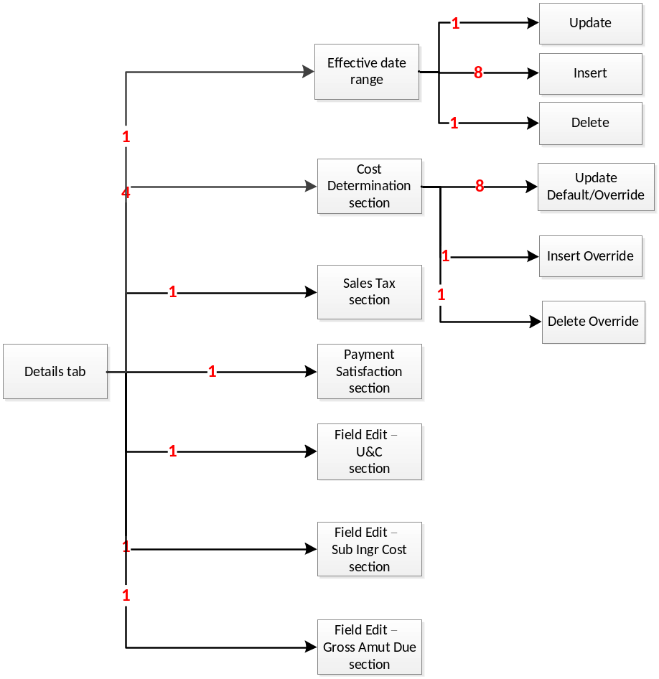
- Client Pricing Options – Detail tab

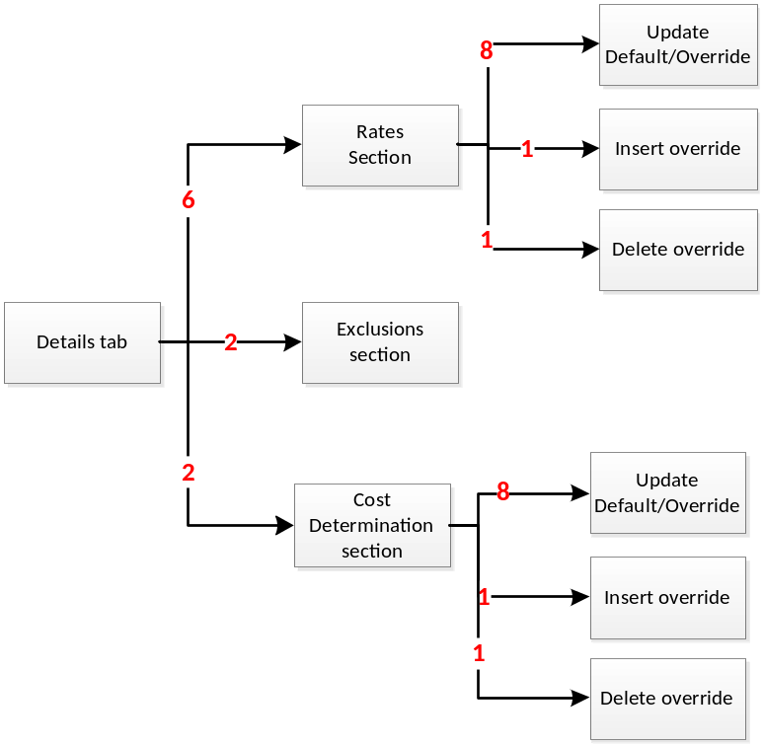
- Client Pricing Rate Sheet – Detail Tab

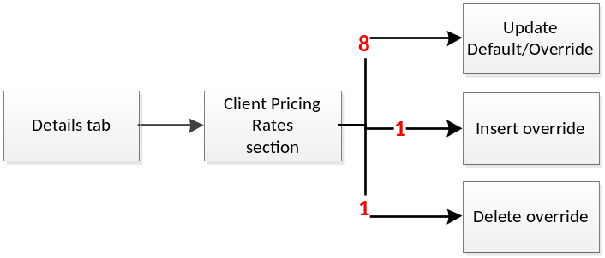

- Import

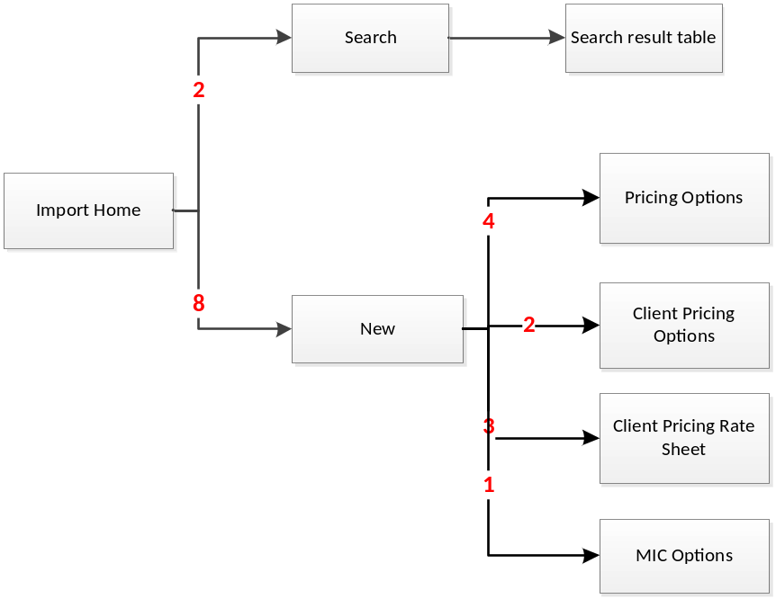

- Reporting tab

There are four report type: Component Association, Compare Component, Component Summary, Component Full detail.

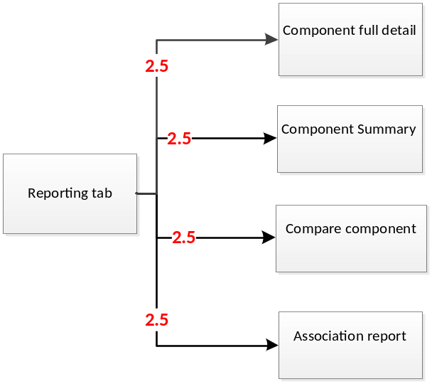

Below is the workflow of new a pricing component.

- New a Pricing Option component (PS)

Num | Section Name | Default | Override
1 | Cost Determination | Required | Optional.  Condition ID hyperlink.
2 | Sales tax | Required  Pharmacy tax list hyperlink | Optional  Pharmacy tax list hyperlink  Condition ID hyperlink.
3 | Payment Satisfaction | Required | Optional.  Condition ID hyperlink.
4 | Field Edit - U&C | Required  Message ID hyperlink | Optional  Message ID hyperlink  Condition ID hyperlink.
5 | Field Edit – Sub Ingr Cost | Required  Message ID hyperlink | Optional  Message ID hyperlink  Condition ID hyperlink.
6 | Field Edit – Gross Amt Due | Required  Pharmacy tax list hyperlink | Optional  Pharmacy tax list hyperlink  Condition ID hyperlink.

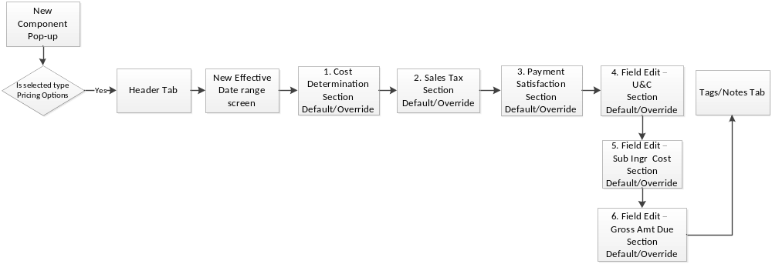
- New a Client Pricing Option component (CS)

Num | Section Name | Default | Override
1 | Rates | Required  Rate sheet ID hyperlink | Optional  Rate sheet ID hyperlink  Condition ID hyperlink.
2 | Exclusions | Required | Optional  Condition ID hyperlink.
3 | Cost Determination | Required | Optional.  Condition ID hyperlink.

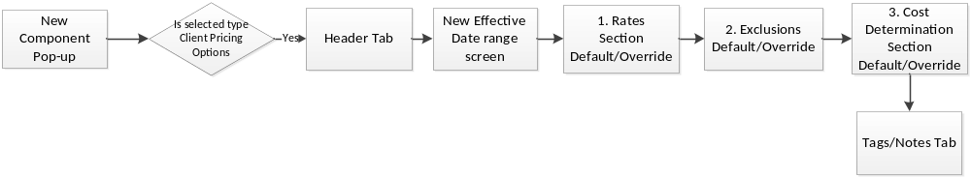
- New a Client Pricing Rate sheet component (CR )

Num | Section Name | Default | Override
1 | Client Rate Rates | Required  MAC Component ID hyperlink | Optional  MAC Component ID hyperlink Condition ID hyperlink.

- New a MIC Option component （MP）
Num | Section Name | Default | Override
1 | Ingr Cost Determination | Required | Optional  Condition ID hyperlink.
2 | Benchmarks Display | Required | Optional  Condition ID hyperlink.

